**Cariboo Lake Results Draft**

By Alex Cebulski

June 9, 2020

Revision 1

**Sub-bottom Acoustics**

Acoustic stratigraphy from six transects conducted across Cariboo Lake reveal the morphology of sediment deposition in Cariboo Lake (Fig. 2). Acoustic penetration is limited in transects proximal to river deltas across Cariboo Lake and improves along the thalwag of acoustic transects distal from river deltas revealing well-layered sediment deposits (Fig. 1). Cross-hatching is observed over most of the acoustic record due to electrical interference from the research vessel but does not affect the quality of the results (Fig. 3-8).

Transect A, one kilometre southwest of the Cariboo River delta, has a strong acoustic reflector along the sediment-water interface indicating the presence of course-grained material on the bed surface (Fig. 3). A high fraction of sand grains in this transect act as an acoustic mask limiting the penetration of the acoustic signal to a depth of 1-2 m along this transect. An acoustic multiple is observed 45 m below the sediment surface (Fig. 2). Acoustically penetrable, well-layered sediment is observed 3.5 km from the Cariboo River delta in transect B (Fig. 4). Acoustic reflectors with 1-2 m spacing lies conformably over a hummocky basement, with a maximum observable sediment thickness of 15-20 m observed near the thalwag. An acoustic multiple is observed just over 20 m below the surface on the south end of the transect (Fig. 4, i).

Acoustic penetration increases 4.4 km from the Cariboo River delta at transect C (Fig. 5). The acoustic record along this transect reaches a maximum sediment thickness of 35 m; the maximum thickness of surficial sediments observed across Cariboo Lake in this study. The acoustic basement is considered to be either bedrock or coarse-grained glacial sediment from the Last Glacial Maximum (Fig. 5, i). Two sediment facies are observed across this transect based on geometry and the strength and continuity of reflectors. Some disruption of these facies is caused by turbidity currents and slumping of side slopes. The lower unit, facies A has a thickness of ~ 12 m along undisturbed sections (Fig. 5, A), and historically may have been thicker prior to significant scouring events (Fig. 5, ii & iii). Two sharp crested v-notch channels, not completely infilled with Holocene sediment, are inferred to be scour channels formed by past glacial activity that predates the overlying sediment (Fig. 5, ii & ii). Disturbance within the v-notch channels may be indicative of the presence of strong turbidity currents due to increased glacial activity. Facies A is generally lighter in colour indicating low reflectance and suggests a clastic poor sediment environment. Parallel reflectors along facies A have a gradual transition between high and low levels of reflectance with the absence of distinct erosive contacts.

Facies B begins with high-amplitude parallel reflectors with 2-3 m spacing and conforms well to facies A outside of areas of disturbance, which are due to slumping and turbidity currents (Fig. 5, B). Facies B has a thickness of ~ 10 m along undisturbed sections and deepens to a maximum of 13 m within the scour channels (Fig. 5, ii & iii). The strength of reflectors in facies B are stronger than those in facies A indicating a more erosive environment during this time period. The strength of reflectors gradually decreases moving upwards and spacing thins to sub metre near the surface. The gradual decrease in reflectance is interrupted by a strong reflector at the top of facies B along the sediment-water interface. Along the north sidewall of the transect C sediment slumping interrupts the conformed layering of sediment to the acoustic basement.

Transect D, to the northeast of the Frank Creek delta has well-layered sediments in the top 5-10 m and transitions poor acoustic penetration below this (Fig. 6). The parallel reflectors observed in the top section of transect D have a thickness of 2-3 m and higher amplitude compared to facies B in transect C. The scour channels observed in transect C are less pronounced in this transect (Fig. 6, i & ii). Some slumping of sidewall sediments is observed on the south sidewall (Fig 6, iii)

Southwest of the Frank Creek delta, acoustic reflectors along transect E show a decline in reflectance and a decrease in layer thickness to < 1 m. Acoustic masking from course grained sediment occurs at depths of 2-4 m (Fig. 7). The sedimentary environment southwest of the Frank Creek delta is comparably different to transects northeast of the delta. Further inference of these data suggests that much of the suspended sediment transported from the Cariboo River does not make it past the shallow lake depths (< 20 m) of the Frank Creek delta. This likely results in an increase in sediment deposition northeast of the Frank Creek Delta, which may explain the increase in reflector thickness and amplitude along transect D (Fig 6, 7).

Similar to the Frank Creek basin, the Keithley Creek basin is expected to have reduced connectivity to the main Cariboo Lake basin due to the shallow lake bathymetry (< 10 m) of the Keithley Creek delta (Fig. 1). Transect F, located close to the centre of the Keithley Creek basin shows a maximum observable sediment thickness of 4 m (Fig. 8). Below this is inferred to be acoustic masking due to courser grained sediment. The acoustic reflectors within the top 4 m of transect F are acoustically penetrable, well layered and are conformable to the basin morphology. Reflectors are of higher amplitude compared to those in transect E and thicker at 1-2 m. The reflectors across this transect are inferred to be primarily sediments deposited by Keithley Creek. Due to the close proximity < 1 km to the Keithley Creek delta sediment along this transect likely have a high fraction of sand which limits the acoustic penetration to 4 m.

**Figures**

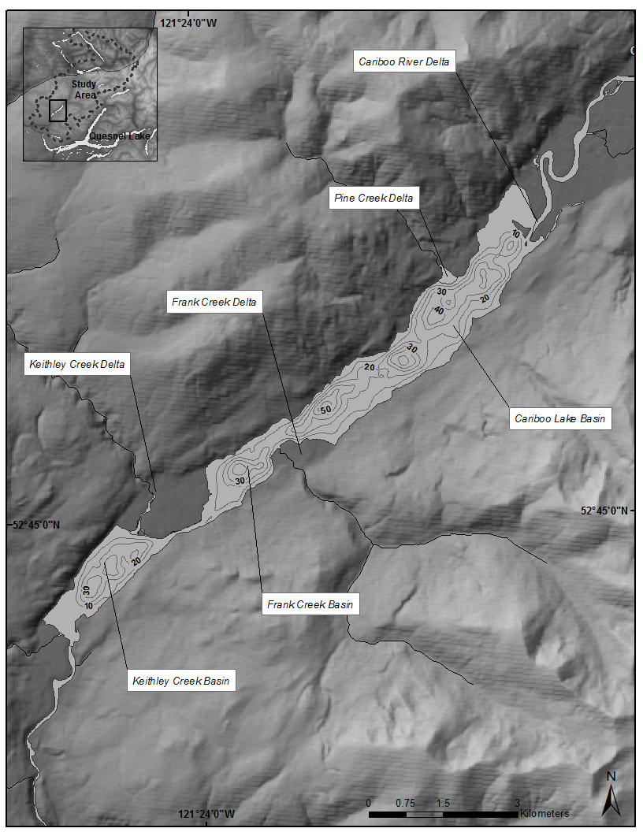

Fig. 1: Cariboo Lake bathymetry. Contour interval is 10 m.

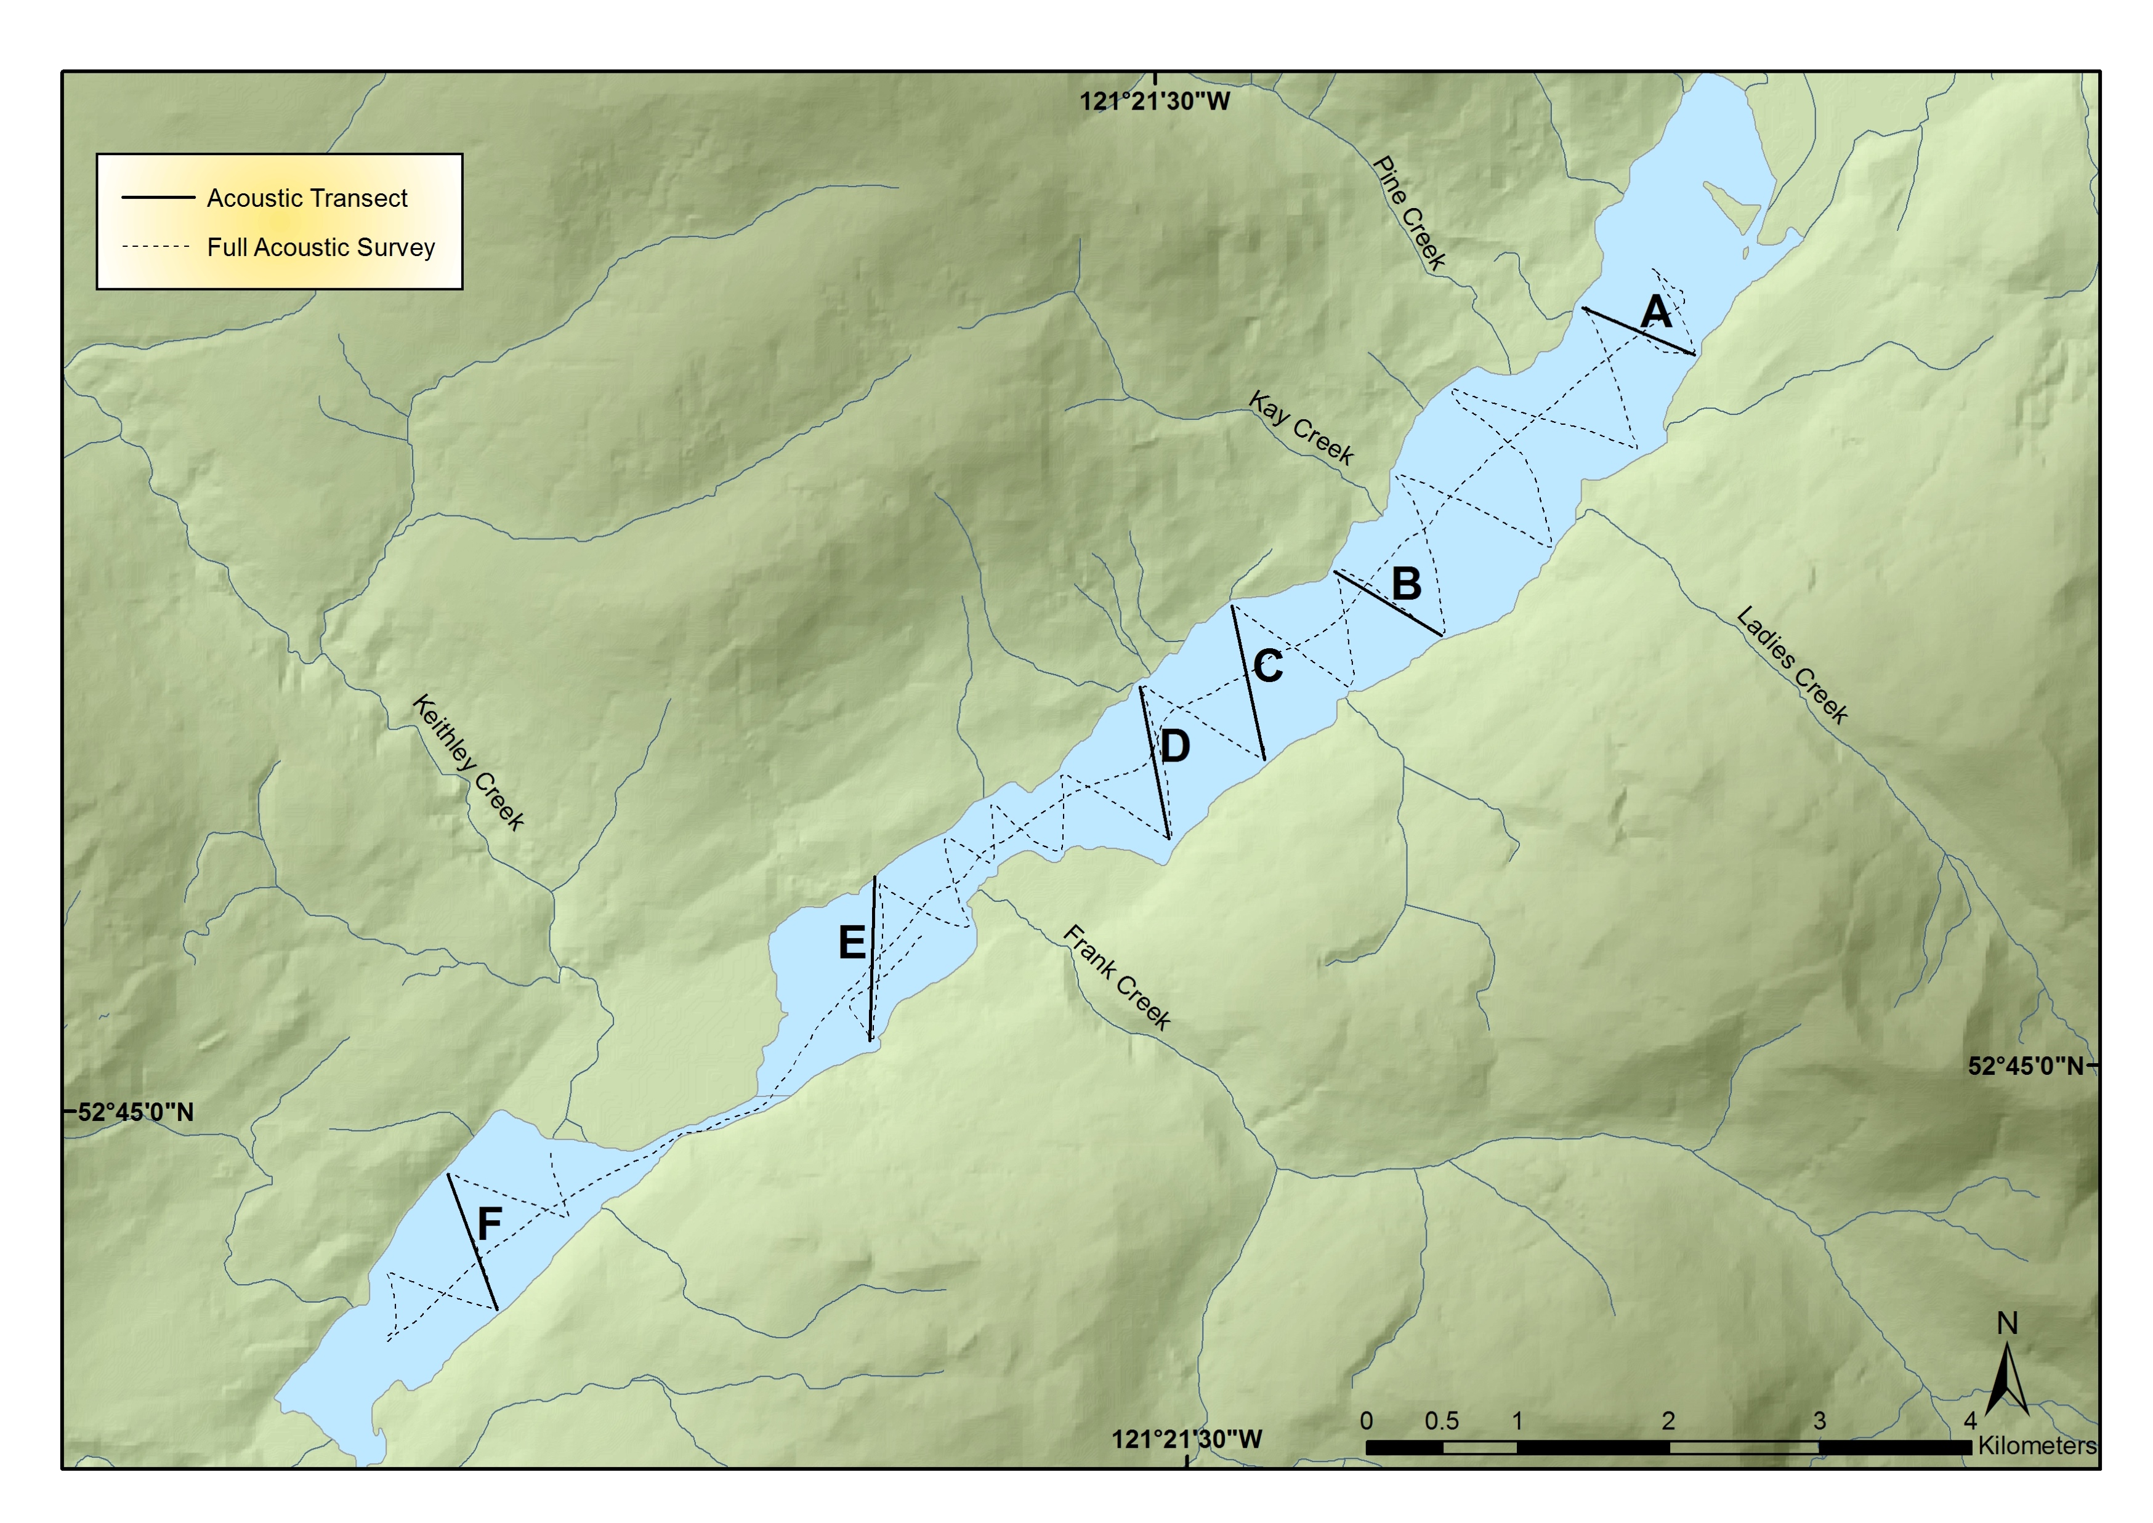

Fig. 2: Cariboo Lake sub-bottom acoustic transects

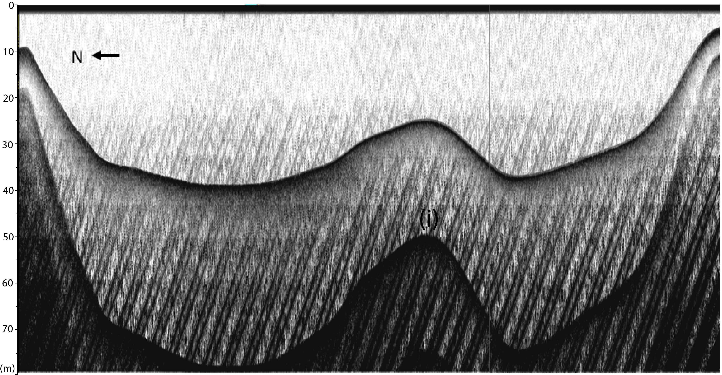

Fig. 3: Sub-bottom acoustic transect A. Duplicate acoustic reflector is denoted by (i). Looking up-lake, see Fig. 3.5 for location.

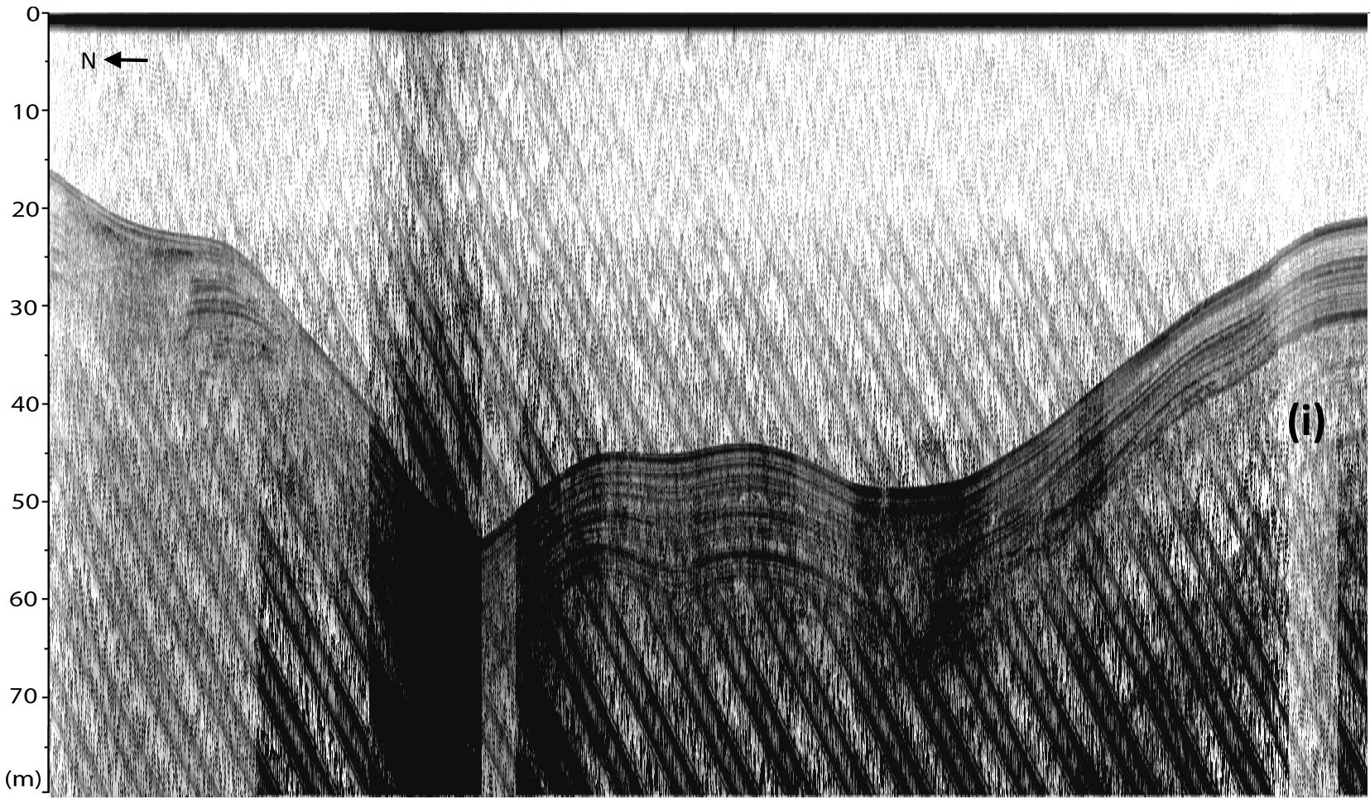

Fig. 4: Sub-bottom acoustic transect B. Looking up-lake, see Fig. 3.5 for location.

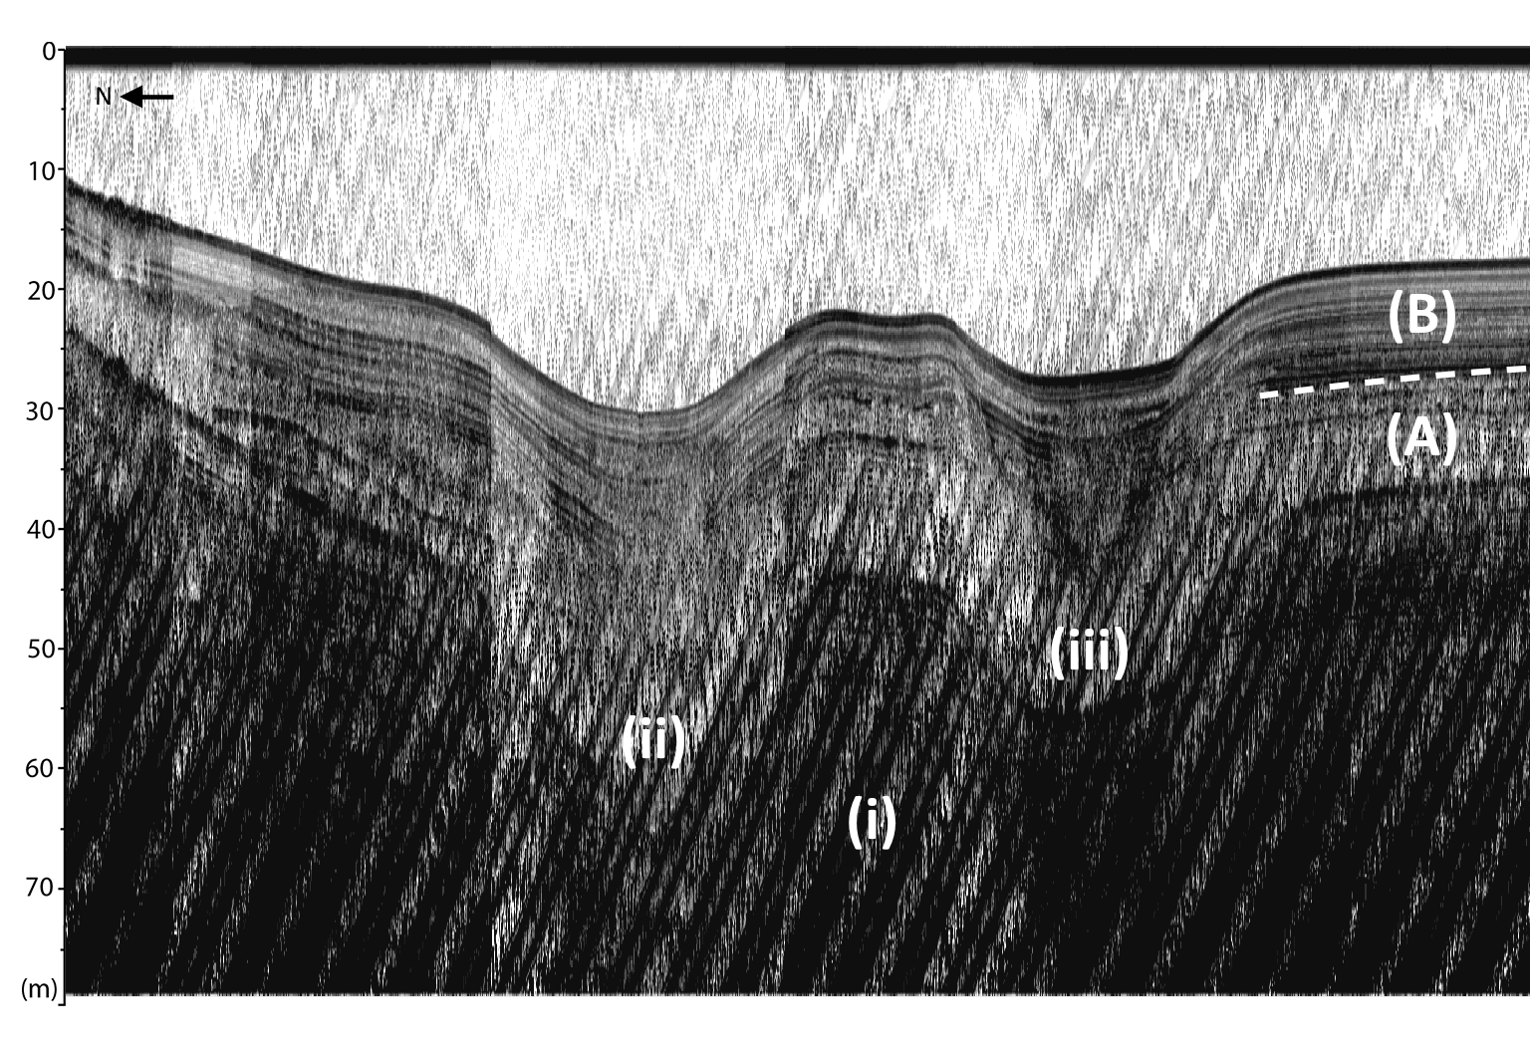

Fig. 5: Sub-bottom acoustic transect C. (i) denotes inferred bedrock or late-glacial material. (ii) and (iii) are v-notch scour channels. (A) and (B) are sediment facies. Looking up-lake, see Fig. 3.5 for location.

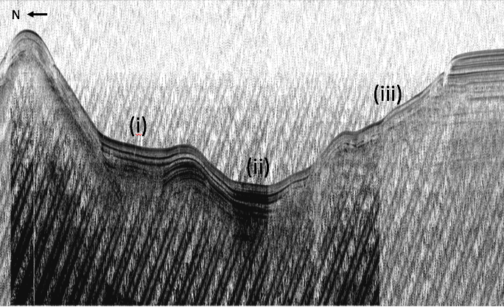

Fig. 6: Sub-bottom transect D. Scour channels are denoted by (i) and (ii). Slumping is observed at (iii). Looking up-lake, see Fig. 3.5 for location.

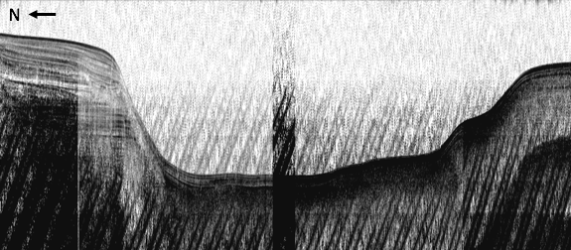

Fig. 7: Sub-bottom acoustic transect E. Looking up-lake, see Fig. 3.5 for location.

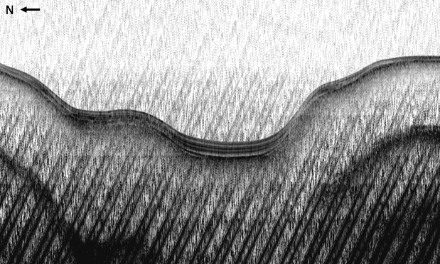

Fig. 8: Sub-bottom acoustic transect F. Looking up-lake, see Fig. 3.5 for location.